Unit 6: Open Economy: International Trade and Finance

Foreign exchange market

Topic 1: Demand for and supply of foreign exchange

Difficulty Level 2

- Suppose that the United States and China are the only trading partners in the world. If the U.S. lowers import restrictions from China, then
  - the demand for U.S. dollars will increase, appreciating the dollar
  - the demand for Chinese yuan will increase, appreciating the yuan
  - the demand for Chinese yuan will increase, appreciating the dollar
  - the supply of U.S. dollars will increase, appreciating the dollar
  - the demand for Chinese yuan will decrease, appreciating the dollar
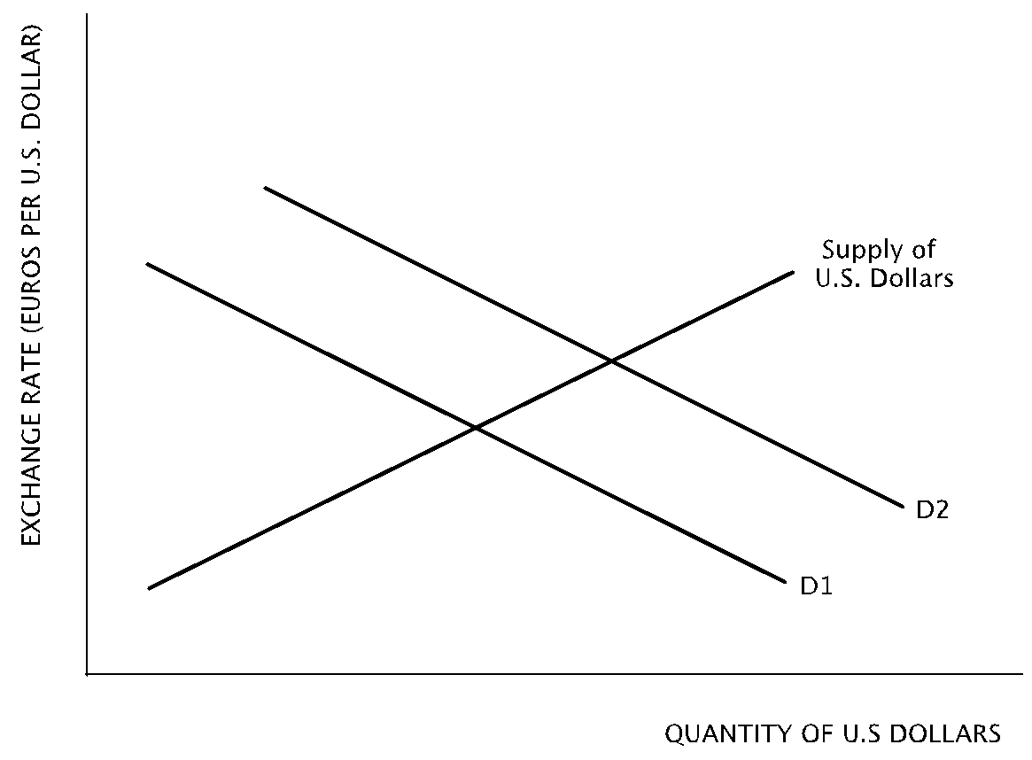
Use the graph below to answer the following questions.
- According to the graph, a shift from D1 to D2 represents
  - an increase in demand for euros
  - an increase in demand for U.S. dollars
  - an increase in supply of U.S. dollars
  - a decrease in demand for euros
  - a decrease in demand for U.S. dollars
- Which of the following causes the shift from D1 to D2 depicted in the graph?
  - An increase in the United States’ demand for European goods
  - An increase in the price level in the United States
  - A decrease in the price level in Europe
  - A decrease in United States tariffs on European goods
  - United States interest rates are higher than European interest rates
- How is the supply of and demand for United States dollars affected by an increase in purchases of capital goods by American companies in India?
Supply of U.S. dollars Demand for U.S. dollars
  - Increase Increase
  - Increase Decrease
  - Increase No change
  - Decrease Increase
  - No change Decrease
- Which of the following changes will occur in the foreign exchange market for United States dollars if investors in the United States and in other nations increase their purchases of United States financial assets such as stocks and bonds?
Demand for U.S. dollars Supply of U.S. dollars
  - Increase Increase
  - Decrease Increase
  - No change Increase
  - Increase Decrease
  - Increase No change
- Assuming American tourists increase their visits to Brazil, how will the foreign exchange markets for the U.S. dollar and the Brazilian real be affected?
  - The supply of the U.S dollar will increase and the supply of the Brazilian real will decrease
  - The demand for both currencies will increase
  - The supply of the U.S. dollar will increase and the demand for the Brazilian real will increase
  - The supply of both currencies will increase
  - The demand for the U.S. dollar will increase and the supply of the Brazilian real will increase
- Suppose that Russia, whose currency is the ruble, is experiencing high inflation relative to the United States, whose currency is the dollar. Which of the following would occur in the foreign exchange market?
  - An increase in the demand for the Russian ruble
  - An increase in the demand for the U.S. dollar
  - A decrease in the demand for the U.S. dollar
  - An decrease in the supply of the Russian ruble
  - No change in the supply of the Russian ruble
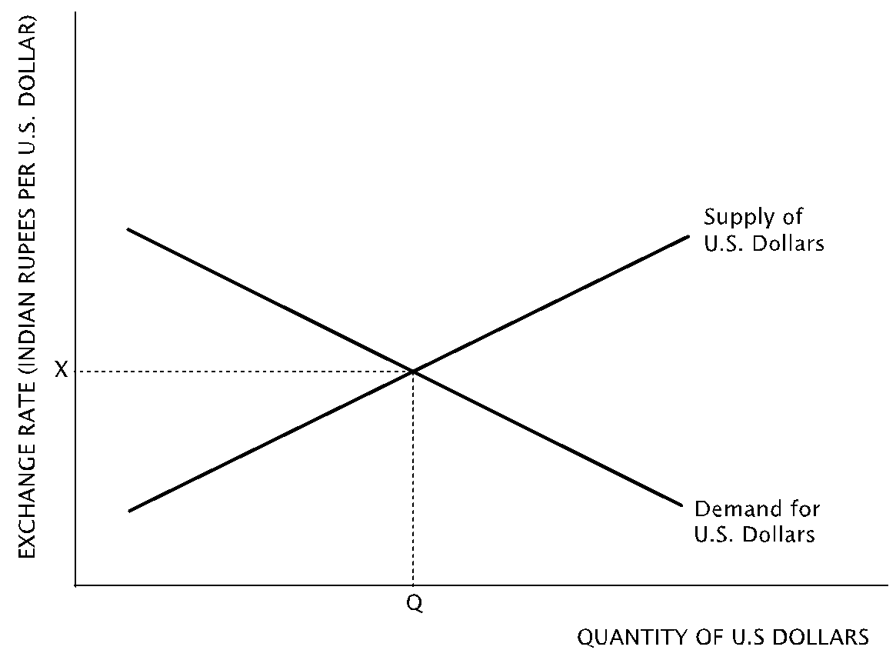
- Suppose that Britain and the United States were the only trading partners in the world. If the income of British citizens increases relative to income of American citizens, there will likely be an increase in which of the following?
  - Demand for the British pound and the supply of U.S. dollars
  - Demand for both British pounds and U.S. dollars
  - Supply of both British pounds and U.S. dollars
  - Supply of the British pound and demand for the U.S. dollar
  - Exports from Britain and imports to the U.S.

Topic 2: Exchange rate determination

Difficulty Level 1
- Which of the following refers to the price of one economy’s currency expressed in terms of another economy’s currency?
  - Real interest rate
  - Nominal interest rate
  - Comparative advantage
  - Exchange rate
  - Terms of trade

Difficulty Level 2
Use the graph below to answer the following question.
- According to the graph, how will the supply of U.S. dollars and the exchange rate be affected by an increase in investment spending in India by United States firms?
Supply of U.S. Dollars Exchange Rate
  - Leftward shift Increase
  - Leftward shift Decrease
  - Rightward shift Increase
  - Rightward shift Decrease
  - No change No change
- Which of the following changes will occur in the foreign exchange market for United States dollars if investors from abroad increase their purchases of U.S. government bonds?
Demand for U.S. dollars Value of U.S. dollar
  - Increase No change
  - Decrease Depreciates
  - No change No change
  - Increase Appreciates
  - Increase Depreciates
- An increase in exports from the United States to nations overseas will result in which of the following in foreign exchange markets?
  - A increase in the value of the United States dollar
  - An increased supply of the United States dollar
  - Decreased United States demand for foreign currencies
  - An increase in the value of foreign currencies
  - A decrease in foreign demand for United States dollars

- Assume that the inflation rate in Venezuela is very high relative to the inflation rates in all of its trading partners. Which of the following is likely to happen to Venezuala’s currency, the bolivar, on the foreign exchange market?
  - Demand for the Venezuelan bolivar will increase, and the currency will appreciate
  - Demand for the Venezuelan bolivar will decrease, and the currency will depreciate
  - Demand for the Venezuelan bolivar will not change, but the currency will depreciate
  - The supply of the Venezuelan bolivar will decrease, and the currency will appreciate
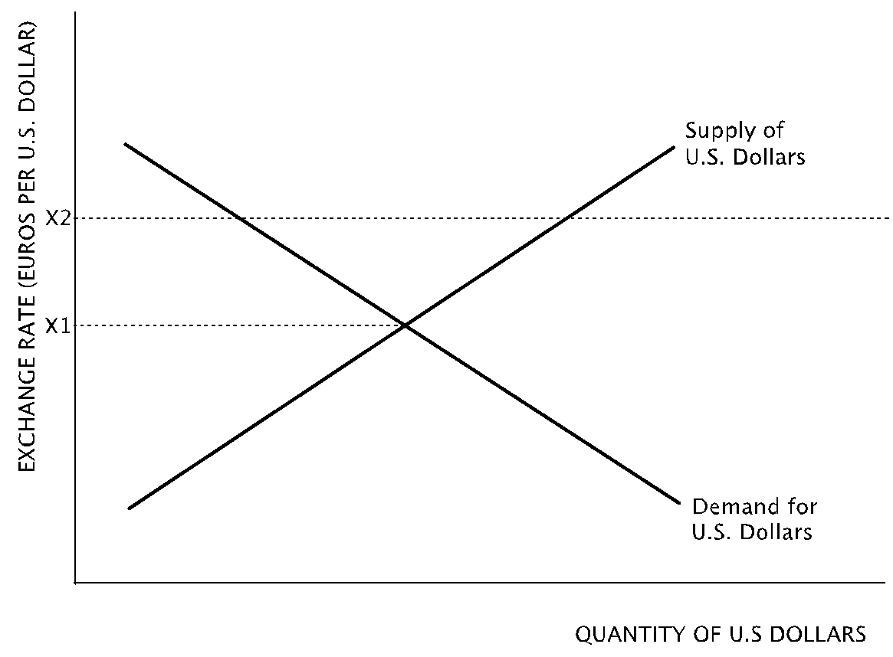
  - The supply of the Venezuelan bolivar will decrease, and the currency will depreciate
- A depreciation of the Mexican peso on the foreign exchange market could be caused by an increase in which of the following?
  - Purchases of Mexican goods and services by its trading partners
  - Foreign tariffs on Mexican goods exported to its trading partners
  - Mexican interest rates
  - Inflation rates among Mexico’s trading partners
  - Demand for the Mexican peso
- Which of the following changes will likely cause an appreciation in the value of the U.S. dollar on the foreign exchange market?
  - Interest rates in Canada increase relative to interest rates in the United States
  - Americans begin to prefer domestically produced goods to foreign-produced goods
  - Inflation rates in the United States rise relative to its trading partners
  - American currency speculators increase their purchases of Asian currencies
  - American oil refineries increase their demand for crude oil from Saudi Arabia

Use the graph below to answer the following question.
- According to the graph, which of the following changes will result in a change in the exchange rate from X1 to X2?
  - American investors speculate that the euro will increase in value
  - European-made fashions grow in popularity among Americans
  - American manufacturers shift production to European factories
  - The inflation rate in the United States increases relative to Europe
  - U.S. Treasury bonds increase in value relative to European financial assets

Topic 3: Currency appreciation and depreciation

Difficulty Level 2
- An increase in the value of the United States dollar on foreign exchange markets will most likely benefit
  - German citizens who desire to purchase real estate in the United States
  - U.S. restaurant owners who regularly import French and Chilean wine
  - South Korean tourists on vacation in the United States
  - A retired Italian living in the United States who receives Italian pension checks
  - A U.S. auto producer who sells cars and trucks overseas
- Which of the following will lead to a depreciation of a nation’s currency?
  - An increased demand for the nation’s currency
  - Decreased real interest rates in the nation compared with the rest of the world
  - An increase in exports
  - A lower price level in the nation relative to the rest of the world
  - A decreased demand for imports among the nation’s citizens
- The value of a country’s currency will tend to appreciate if
  - demand for the country’s exports decreases
  - foreigners investors speculate that the country’s currency will increase in value
  - the country’s firms increase their investment spending abroad
  - domestic inflation rates increase
  - the country’s citizens increase their purchases of foreign goods
- Which of the following is true if price level has been rising in Canada relative to the price level in the United States?
  - The Canadian dollar will have appreciated relative to the United States dollar.
  - The Canadian dollar will have depreciated relative to the United States dollar.
  - Canada is experiencing a recession while the United States economy is experiencing growth
  - The United States’ money supply is growing at a faster rate than Canada’s
  - Real interest rates are increasing in the United States relative to Canada’
- Which of the following would cause the Mexican peso to appreciate relative to the United States dollar?
  - An increase in Mexico’s inflation rate
  - An increase in Mexico’s interest rates relative to the United States’ interest rates
  - An increase in Mexican household income
  - An increase in United States household income
  - An increase in Mexico’s imports
- Which of the following will benefit from a depreciation of the United States dollar on the foreign exchange market?
  - An American firm that sells services to customers abroad
  - A Swedish firm that sells services to customers in the United States
  - An American investor intending to purchase a factory in China
  - An Indian computer programmer hired by a firm in the United States
  - A German firm that sells goods exclusively in Europe
- If Chinese firms and citizens increase their investment in the United States, the supply of Chinese yuan to the foreign exchange market and the dollar price of the yuan will likely change in which of the following ways?
Supply of Chinese Yuan Dollar Price of Yuan
  - Increase Increase
  - Increase Decrease
  - Decrease Increase
  - Decrease Decrease
  - Decrease No change
- If the international value of the United States dollar depreciates in comparison to the European Union’s euro currency, which of the following is likely to occur?
  - The United States government will enact trade quotas on European imports.
  - Trade between the United States and Europe will not be affected.
  - United States exports to Europe will increase.
  - The United States will increase its balance of trade deficit with Europe.
  - United States investors will increase purchases of European financial assets

1 | B | 6 | C | 11 | D | 16 | E | 21 | D | 21 | A
2 | B | 7 | B | 12 | A | 17 | B | 22 | A | 22 | C
3 | E | 8 | D | 13 | B | 18 | B | 23 | B | 23 | C
4 | C | 9 | D | 14 | B | 19 | B | 24 | C | 24 | C
5 | E | 10 | D | 15 | B | 20 | B | 25 | D | 25

Answers - Unit 6: Open Economy: International Trade and Finance

Foreign exchange market

Topic 1: Demand for and supply of foreign exchange

Difficulty Level 2
- Correct answer: B
A decrease in import restrictions from China will encourage Americans to purchase Chinese goods and services. Americans will supply more dollars to the foreign exchange market and demand more Chinese yuan. This will cause the U.S. dollar to depreciate and the Chinese yuan to appreciate in value.
- Correct answer: B
The graph is showing a rightward shift in demand, which means that the quantity of U.S. dollars demanded at various exchange rates is increasing, i.e., demand for the U.S. dollar is increasing.
If there is confusion as to whether the graph represents U.S. dollars or euros, refer to the label on the horizontal axis for clarification.
Incorrect Answer
It looks like demand is shifting to the right, but which currency does it represent? Refer to the label on the horizontal axis for clarification.
- Correct answer: E
The shift of demand represented by the graph occurs when Europeans increase their demand for the U.S. dollar. Such a shift occurs when Europeans hope to make purchases or investments in the United States. If U.S. interest rates are higher than European interest rates, then Europeans will increase their demand for U.S. dollars so they can purchase American financial assets.
Incorrect Answer
Be sure to understand the shift before searching for the correct answer. Europeans are increasing their demand for the U.S. dollar
- Correct answer: C
American companies who purchase capital goods in India must supply more U.S. dollars to the foreign exchange market to purchase more Indian rupees. Since the question gives no indication of an increase in Indian demand for American products or assets, there is no change in demand for U.S. dollars.
Incorrect Answer
A nation must supply its own currency to increase purchases in another nation.
- Correct answer: E
One must obtain U.S. dollars to purchase U.S. financial assets, so the demand for U.S. dollars will increase. Since the question offers no indication that Americans are trying to purchase more foreign products or assets, the supply of U.S. dollars in the foreign exchange market remains unchanged.
Incorrect Answer
One must obtain U.S. dollars to purchase U.S. financial assets.
- Correct answer: C
American tourists will increase their purchases of goods and services in Brazil, such as hotel stays, food, and entertainment. For these purchases they will supply more U.S. dollars to the foreign exchange market and demand more Brazilian real.
- Correct answer: B
If inflation is lower in the United States, Russians will demand more American goods as they will be relatively cheaper to purchase. To purchase American goods, Russians will supply more rubles and demand more U.S. dollars.
Incorrect Answer
Approach questions about international trade with the assumption, unless otherwise noted, that the nations referenced may trade freely. If there were free trade, people purchase goods and services where the prices are lowest. In this case, Russians will purchase goods and services from the United States.
- Correct answer: D
When incomes rise, consumers increase their demand for imports. If incomes are rising in Britain relative to the U.S. then British citizens will increase their demand for U.S. goods and services. British citizens will increase their the demand for U.S. dollars and increase the supply of British pounds, which are used to purchase dollars on the foreign exchange market.
Incorrect Answer
When incomes rise, consumers tend to consume more imports.

Topic 2: Exchange rate determination

Difficulty Level 1
- Correct answer: D
The exchange rate is refers to the amount of one nation’s currency that must be supplied to purchase a unit of another nation’s currency on the foreign exchange market.
Incorrect Answer
There are many markets studied in macroeconomics and each one expresses its price with a different term. Purchases of another nation’s currency occur on the foreign exchange market. What term does this market use to represent price?

Difficulty Level 2
- Correct answer: D
An increase in investment spending in India by U.S. firms will require those firms to supply American dollars in order to purchase Indian rupees. The increase in the supply of U.S. dollars will shift that curve to the right, resulting in a decrease in the exchange rate of rupees per dollar. In other words, the rupee will appreciate in value and the dollar will depreciate.
Incorrect Answer
To conduct investment spending in India, U.S. firms will need to first purchase Indian rupees with U.S. dollars.
- Correct answer: D
One must obtain U.S. dollars to purchase U.S. financial assets, so the demand for U.S. dollars will increase. As demand increases for U.S. dollars increases, the equilibrium exchange rate for U.S. dollars increases, making the U.S. dollar appreciate in value relative to foreign currencies.
Incorrect Answer
One must obtain U.S. dollars to purchase U.S. financial assets. How will an increase in purchases of U.S. assets affect the value of the dollar?
- Correct answer: A
An increase in exports from the United States indicates that foreign nations are purchasing more U.S. goods and services. In order to do this, foreigners must demand more U.S. dollars and supply more of their own currencies. These exchanges will result in an increase in the value of the U.S. dollar relative to foreign currencies.
Incorrect Answer
An increase in exports from the United States indicates that foreign nations are purchasing more U.S. goods and services. What will foreigners need to do to make these purchases?
- Correct answer: B
As the inflation rate increases in Venezuela relative to that of its trading partners, its products and assets will rise in cost and foreigners will decrease their demand for them, resulting in a decrease in demand for the Venezuelan bolivar. As a result of declining demand for the Venezuelan bolivar, the currency will depreciate in value.
Incorrect Answer
At higher prices, Venezuela’s trading partners will increasingly find Venezuelan products and assets to be too expensive. How will this situation affect the Venezuelan bolivar in the foreign exchange market?
- Correct answer: B
A depreciation of the Mexican peso will occur if there is a decrease in demand for Mexican products and assets among its trading partners or an increase in Mexicans’ demand for products and assets of its trading partners.
If Mexico’s trading partners place a tariff on goods exported by Mexico, then those partners will decrease their demand for Mexican goods and the Mexican peso. This will result in a depreciation of the peso.
Incorrect Answer
A depreciation of the Mexican peso will occur if there is a decrease in demand for Mexican products and assets among its trading partners or an increase in Mexicans’ demand for products and assets of its trading partners.

- Correct answer: B
An increase in value, or appreciation, of the U.S. dollar occurs when there is an increase in the demand for the U.S. dollar or a decrease in the supply of the U.S. dollar on the foreign exchange market. If Americans begin to prefer U.S.-made goods to foreign-made goods, they will supply fewer dollars to the foreign exchange market, resulting in an appreciation in the U.S. dollar.
Incorrect Answer
An increase in value, or appreciation, of the U.S. dollar occurs when there is an increase in the demand for the U.S. dollar or a decrease in the supply of the U.S. dollar on the foreign exchange market.
- Correct answer: E
To achieve an equilibrium exchange rate at X2 in the graph, demand for U.S. dollars must increase or supply of U.S. dollars must decrease. If financial assets in the U.S. increase relative to those in Europe, European investors will increase their demand for U.S. assets and increase their demand for the U.S. dollar to make those purchases.
Incorrect Answer
To achieve an equilibrium exchange rate at X2 in the graph, demand for U.S. dollars must increase or supply of U.S. dollars must decrease.

Topic 3: Currency appreciation and depreciation

Difficulty Level 2
- Correct answer: B
An increase in the value of the U.S. dollar increases its buying power in other economies, which benefits Americans hoping to purchase foreign products and assets. However, it weakens the buying power of people holding foreign currency who hope to purchase products and assets in the United States.
Incorrect Answer
An increase in the value of the U.S. dollar increases its buying power in foreign economies while weakening the buying power of foreign currencies in the U.S.
- Correct answer: B
If there are decreased real interest rates in the nation compared to the rest of the world, demand for the nation’s currency will decrease and the supply of the nation’s currency will increase. These shifts occur because investors will increase purchases of foreign financial assets to take advantage of the relatively higher real interest rates abroad.
Incorrect Answer
A depreciation of a nation’s currency occurs when demand for its currency decreases or the supply of its currency increases.
- Correct answer: B
For the country’s currency to appreciate, it must be demanded more or supplied less. If foreign investors speculate that the currency will rise in value, they will likely increase purchases of the currency and cause it to increase in value.
Incorrect Answer
The value of a country’s currency will appreciate if it is demanded more or supplied less.
- Correct answer: B
If the price level in Canada has been rising faster than in the United States, Canadians will increasingly purchase products and assets from the United States and Americans will decrease their demand for Canadian products and assets. As a result, demand for the U.S. dollar will increase and the supply of the U.S. dollar will decrese, causing an appreciation of that currency.
Incorrect Answer
According to the question, Canada’s products and assets are becoming more expensive, so Canadians and Americans will likely buy American.
- Correct answer: D
An increase in U.S. household income would increase spending by Americans, including spending on Mexican products. This increase in demand for Mexico’s exports will increase the demand for Mexico’s peso, resulting in its appreciation in value.
Incorrect Answer
Which answer choice causes an increase in demand for the peso or a decrease in supply of the peso?
- Correct answer: A
When the United States dollar depreciates in value, it is a benefit to American sellers of products and assets to customers abroad because foreign currencies appreciate in value and carry more buying power in the U.S.
Incorrect Answer
If the U.S. dollar depreciates in value then foreign curriencies appreciate in value.
- Correct answer: B
If Chinese firms and citizens are increasing investments in the U.S., they are increasing their purchases of American assets. To purchase these assets, Chinese yuan are supplied and U.S. dollars are demanded, which depreciates the value of the yuan (a decrease in the dollar price of the yuan).
Incorrect Answer
If Chinese firms and citizens are increasing investments in the U.S., they are increasing their purchases of American assets.
- Correct answer: C
If the dollar depreciates relative to the euro, then United States products and assets are becoming relatively cheaper to Europeans.
Incorrect Answer
If the dollar depreciates relative to the euro, then United States products and assets are becoming relatively cheaper to Europeans.

